Building a Home SIEM/XDR Lab Using Wazuh

Introduction
As a cybersecurity student focused on SOC operations and incident response, I built this Wazuh home lab to bridge the gap between theoretical knowledge and practical threat detection through the installation and deployment of a SIEM manager and endpoint agents. This environment allowed me to gain hands-on experience in configuring File Integrity Monitoring (FIM) to actively monitor, investigate, and analyze system changes in a realistic setting.

Lab Architecture
The Home SIEM Lab consists of two virtual machines deployed in VMware Workstation:
- Ubuntu Desktop — Hosts the Wazuh server, dashboard, and log management components.
- Windows Endpoint — Generates system and security events for monitoring and analysis.

WHY WAZUH ?
Wazuh is chosen for security labs because it is a powerful, open-source platform that combines SIEM and XDR capabilities without the burden of licensing fees. It enables hands-on experience with real-world security workflows, such as File Integrity Monitoring and centralized log management, across diverse operating systems. By mastering this platform, you gain practical proficiency with the same tools and technical processes used by professional security analysts in corporate environments. Consequently, it serves as an excellent bridge between theoretical knowledge and the technical skills required for a career in cybersecurity.

Installation of Wazuh

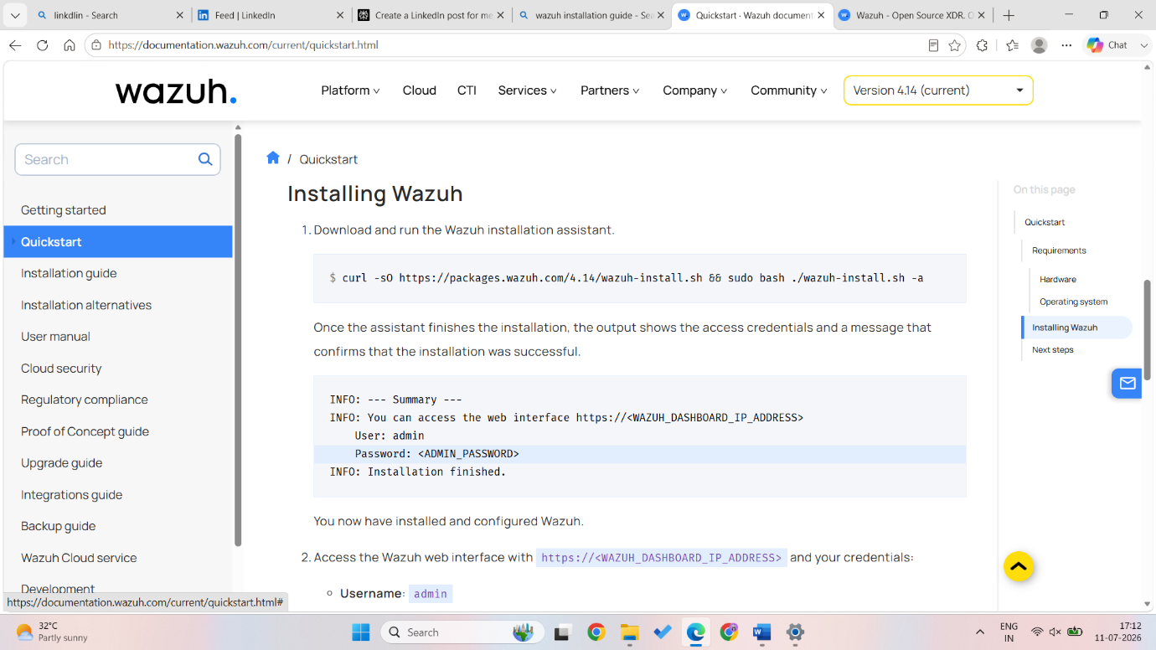

Then add Wazuh GPG Key via a terminal window
curl -s https://packages.wazuh.com/key/GPG-KEY-WAZUH | sudo gpg --dearmor -o/usr/share/keyrings/wazuh-archive-keyring.gpg
This adds the GPG key to verify Wazuh packages.
Then execute the installation script:
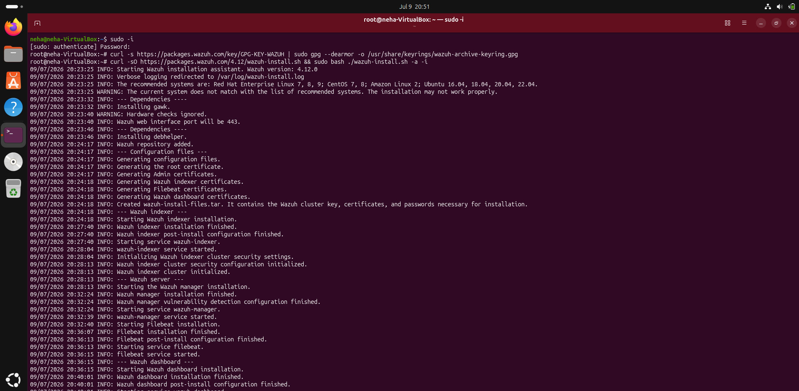

INSTALLATION ISSUE ENCOUNTERED
Problem: The initial deployment failed due to systemic resource exhaustion. By attempting an "all-in-one" batch installation on a resource-constrained virtual environment, the system exceeded its memory capacity, leading to frequent service crashes and kernel-level process termination. These interruptions caused package database corruption, leaving the environment in an unusable state.
Resolution:
- Resource Optimization: Increased the allocated virtual memory to provide sufficient overhead for the Wazuh stack, preventing memory-related crashes and kernel-level terminations.
- System Restoration: Performed a clean rebuild of the virtual machine environment to eliminate filesystem inconsistencies and corrupted partial configurations resulting from the failed attempt.
Deployment Completion
After several minutes of automated configuration, the Wazuh deployment completed successfully. Once the deployment finished, the Wazuh Dashboard service was initialized and made available through a web interface.
ISSUE ENCOUNTERED
Problem: During initial access to the Wazuh web interface, I encountered persistent API token failures and connection timeouts. The root cause was that my hardware-constrained virtual environment required more time to initialize the backend services than the default system timeout allowed. This discrepancy caused the interface to prematurely terminate my session requests before the services were fully loaded and ready to process authentication tokens.
Resolution: Timeout Configuration Adjustment: I investigated the system’s service and API timeout parameters and manually extended the initialization window. By configuring the system to allow a longer duration for service startup and token exchange, I ensured that the backend had sufficient time to stabilize, which successfully resolved the authentication failures and allowed the interface to load consistently.
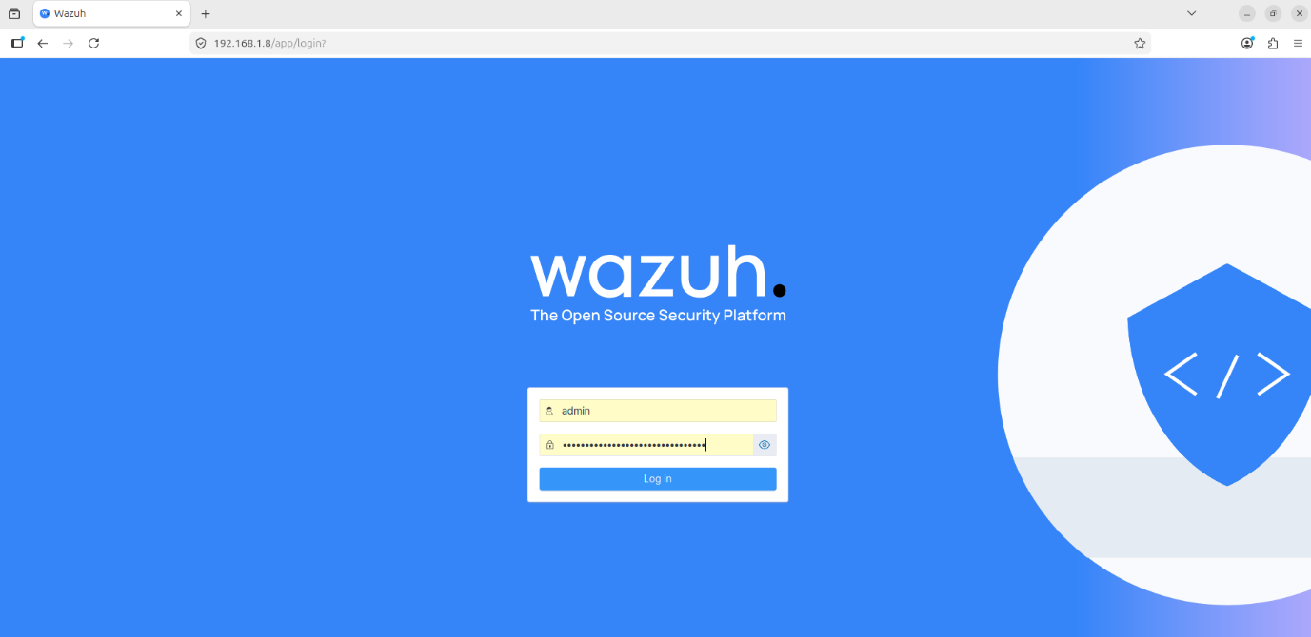

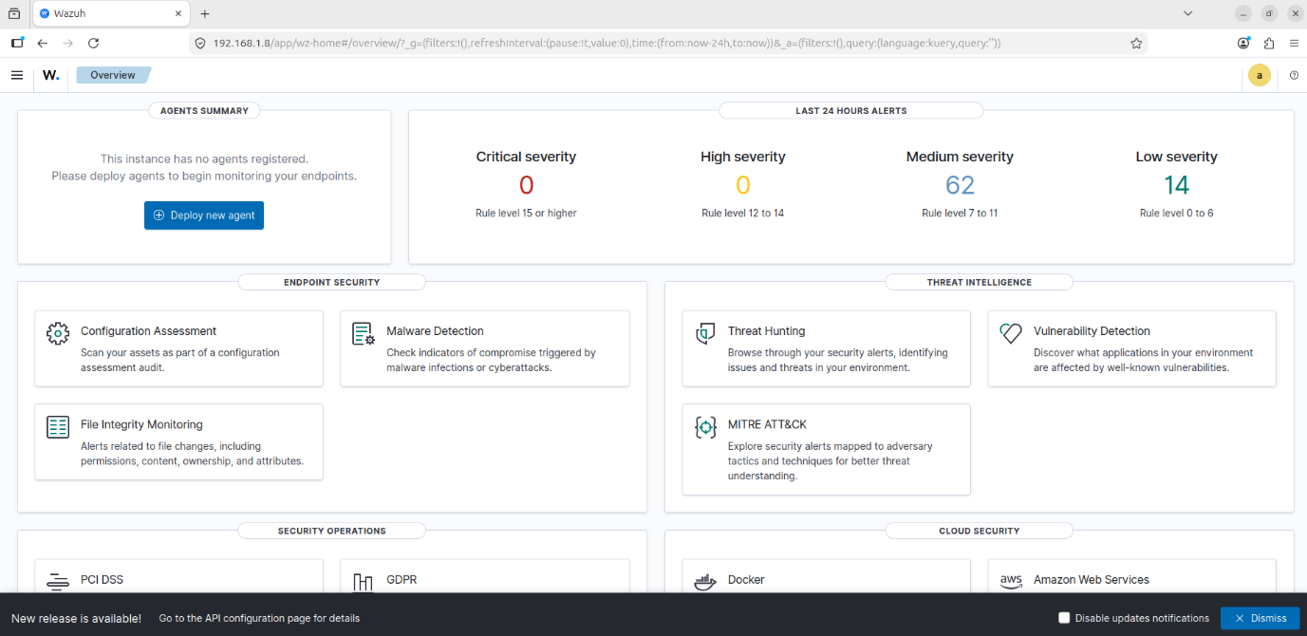
Installing the Wazuh Agent on Windows
I installed the Wazuh Agent on a Windows virtual machine to send security events and system activity to the Wazuh Manager. The agent collects logs from the endpoint and sends them to the Wazuh server.

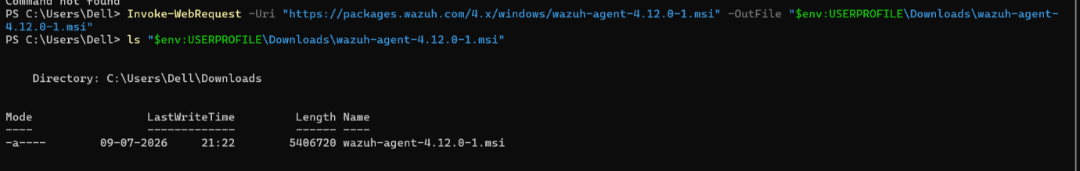

Registering the Agent with the Manager
I initiated the Wazuh agent management tool by executing the
sudo /var/ossec/bin/manage_agents
command in the terminal to begin the enrolment process.
Then I selected the "A" option to add a new agent and assigned it a specific name, such as "neha" to ensure clear identification within the Wazuh Manager.
I left the IP address field blank, allowing for dynamic assignment, as static addressing was not required for this configuration.
After the agent was successfully created, I selected the "E" option to extract the unique enrolment key associated with that agent.
Then I copied the generated key output so that it could be imported into the agent configuration, enabling secure communication between the host and the manager.
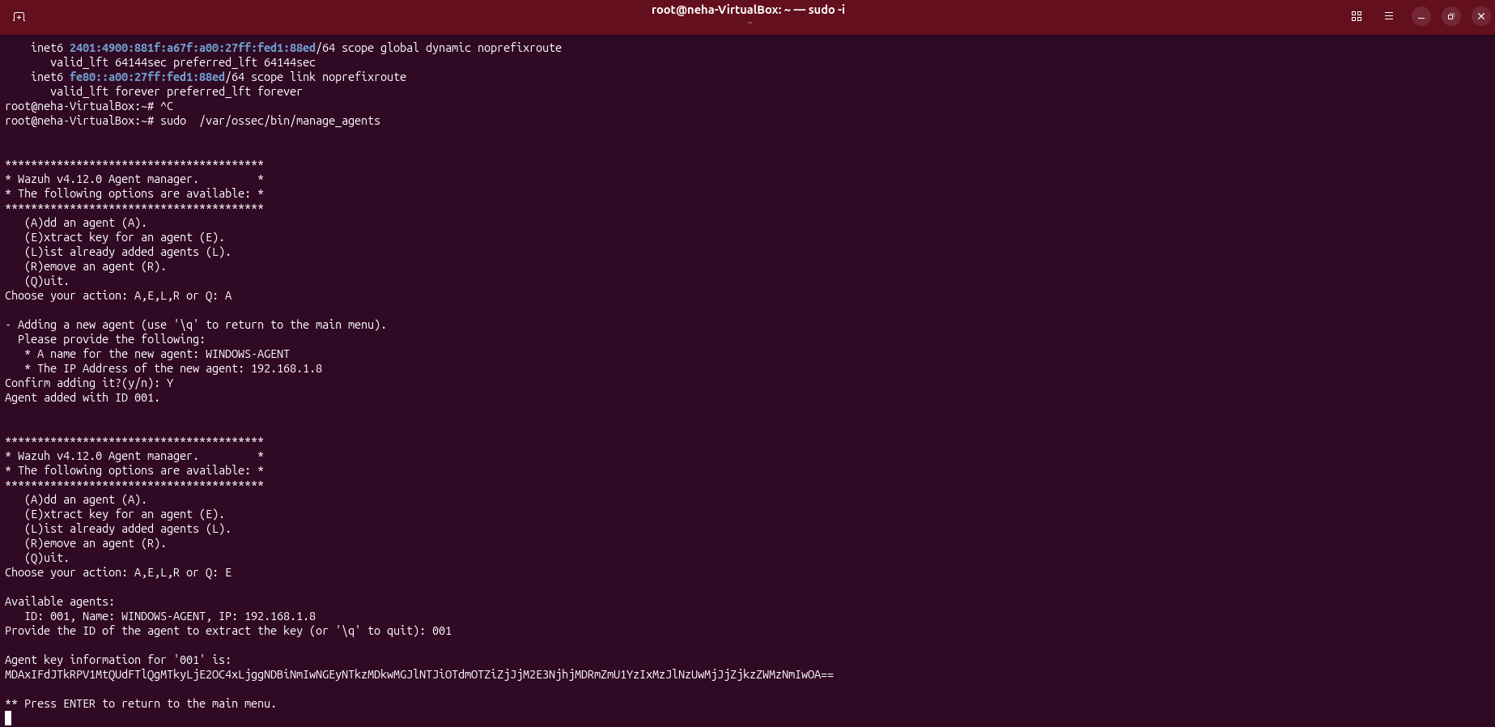

I opened the Wazuh Agent Manager, pasted the enrolment key into the designated field, and saved the configuration to apply the authentication credentials.
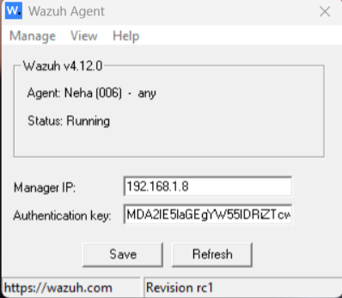

Then I restarted the Wazuh agent service to finalize the setup, which allowed the agent to successfully onboard and appear in the Wazuh dashboard.

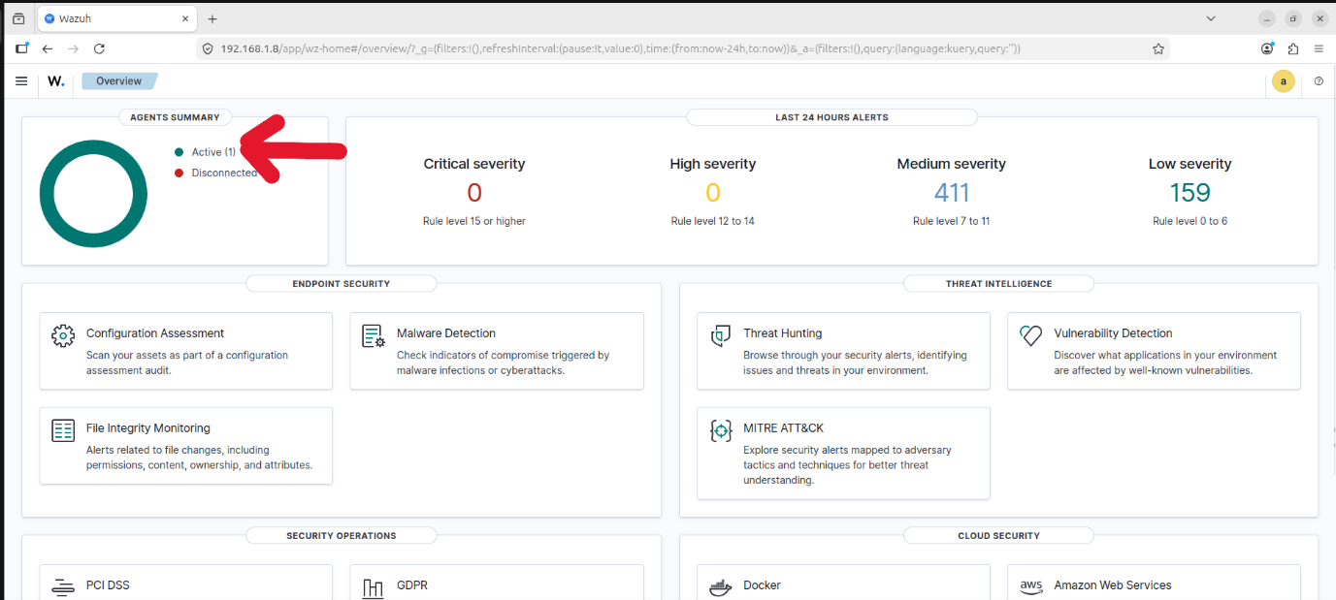

Then I opened the Wazuh agent configuration file located at
C:\Program Files (x86)\ossec-agent\ossec.conf
to configure File Integrity Monitoring (FIM) via Syscheck.
I added the entry <directories realtime="yes">C:\Users\abc\Test</directories> to the configuration block to enable real-time tracking of file and folder modifications for that specific directory.
Then I saved the changes and restarted the Wazuh agent service to apply the updated configuration rules.
After that I accessed the Wazuh Dashboard in my browser and navigated to the "Agents" section to confirm that my Windows agent was listed as "Active."
I proceeded to the "Integrity Monitoring" section to observe real-time system activity.
I performed various actions, such as creating, modifying, and deleting files within the monitored folder, to trigger the monitoring system.
Then I confirmed that the corresponding alerts were successfully generated and displayed on the dashboard, validating the configuration.

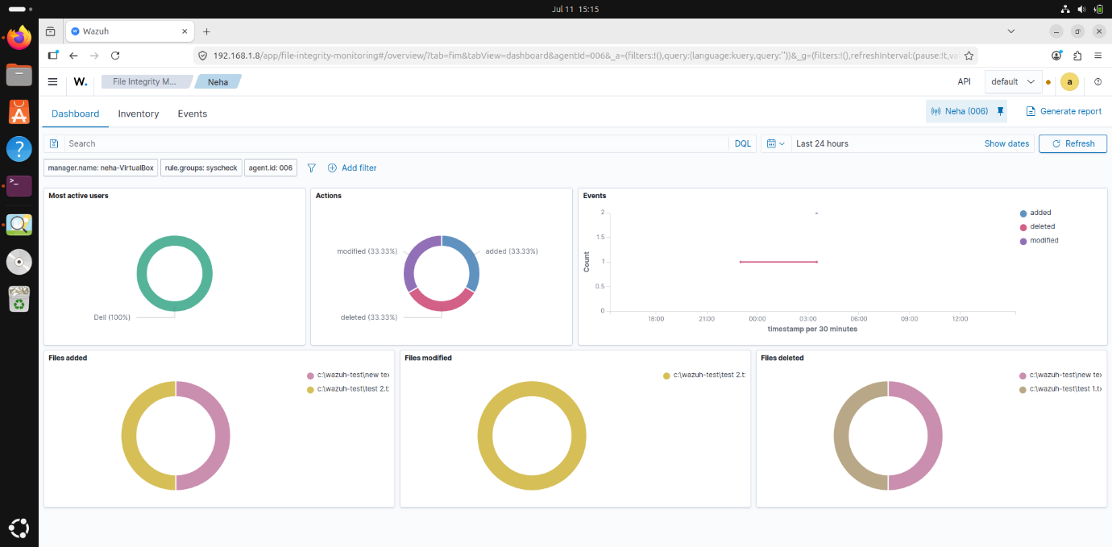

Conclusion
This project successfully demonstrated the core of a functional SIEM by setting up a Wazuh manager and connecting an endpoint agent. By implementing File Integrity Monitoring, I gained hands-on experience in detecting and analyzing system changes in real time. Beyond the technical setup, I also learned the vital importance of persistent troubleshooting when overcoming configuration challenges, which is a key skill for any security analyst.

